**CREATE A HIERARCHY TABLE WITH A RANGE OF DATES BASED ON A COLUMN**

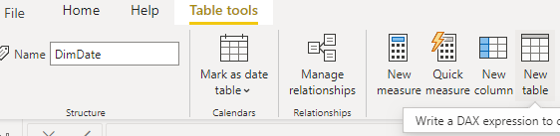

**Table = CALENDAR(MIN(FactInternetSales[OrderDate]),MAX(FactInternetSales[OrderDate]))**

- This is useful if you have an events table with gaps in between dates in the table you are pointing to.

- This only works for date columns, it does not work for string type columns.

**SUM TWO COLUMNS**

Column = TABLENAME[COLUMN_A] + TABLENAME[COLUMN_B]